JUNAID GIRKAR  
60004190057

TE COMPS A4

**EXPERIMENT - 8**

**Aim**

Creating GUI with python containing widgets such as labels, textbox, radio, checkboxes and custom dialog boxes.

**Theory**

Python offers multiple options for developing GUI (Graphical User Interface). Out of all the GUI methods, tkinter is the most commonly used method. It is a standard Python interface to the Tk GUI toolkit shipped with Python. Python with tkinter is the fastest and easiest way to create the GUI applications. Creating a GUI using tkinter is an easy task. To create a tkinter app:

· Importing the module – tkinter

· Create the main window (container)

· Add any number of widgets to the main window

· Apply the event Trigger on the widgets.

The basic code used to create the main window of the application is:

m=tkinter.Tk() where m is the name of the main window object

mainloop(): There is a method known by the name mainloop() is used when your application is ready to run. mainloop() is an infinite loop used to run the application, wait for an event to occur and process the event as long as the window is not closed.

m.mainloop()

Some widgets (like text entry widgets, radio buttons and so on) can be connected directly to application variables by using special options: variable, textvariable, onvalue, offvalue, and value. This connection works both ways: if the variable changes for any reason, the widget it's connected to will be updated to reflect the new value. These Tkinter control variables are used like regular Python variables to keep certain values. It's not possible to hand over a regular Python variable to a widget through a variable or textvariable option. The only kinds of variables for which this works are variables that are subclassed from a class called Variable, defined in the Tkinter module. They are declared like this:

· x = StringVar() # Holds a string; default value ""

· x = IntVar() # Holds an integer; default value 0

· x = DoubleVar() # Holds a float; default value 0.0

· x = BooleanVar() # Holds a boolean, returns 0 for False and 1 for True

Tkinter imports used:

1. Label: It refers to the display box where you can put any text or image which can be updated any time as per the code.

The general syntax is:

w=Label(master, option=value)

master is the parameter used to represent the parent window.

2. RadioButton: It is used to offer multi-choice option to the user. It offers several options to the user and the user has to choose one option.

The general syntax is:

w = RadioButton(master, option=value)

3. OptionMenu: OptionMenu is basically a dropdown or popup menu that displays a group of objects on a click or keyboard event and lets the user select one option at a time.

w = OptionMenu(master, option=value)

4. Button:To add a button in your application, this widget is used.

The general syntax is:

w = Button(master, option=value)

5. CheckButton: To select any number of options by displaying a number of options to a user as toggle buttons. The general syntax is:

w = CheckButton(master, option=value)

6. Text: To edit a multi-line text and format the way it has to be displayed.

The general syntax is:

w = Text(master, option=value)

**Code**

| import tkinter as tk from tkinter import Label, IntVar, Radiobutton, StringVar, OptionMenu, Button, Checkbutton, Text import tkinter.messagebox  def onClick():  tkinter.messagebox.showinfo("Alert", "Form submitted successfully!")  root = tk.Tk() root.geometry("500x500") root.configure(bg="black") root.title('Registration form')  registrationFormTitle = Label(  root,  text="Registration form",  width=20,  font=("bold", 20),  bg="#0066CC", ).place(anchor=tk.CENTER, relx=0.5, rely=0.1)  nameLabel = Label(  root,  text="Name:",  width=20,  font=("bold", 10),  bg="#0066CC" ).place(anchor=tk.CENTER, relx=0.3, rely=0.2)  nameEntry = Text(  root,  height=1.45,  width=25,  bg="#0066CC" ).place(anchor=tk.CENTER, relx=0.7, rely=0.2)  emailLabel = Label(  root,  text="Email",  width=20,  font=("bold", 10),  bg="#0066CC" ).place(anchor=tk.CENTER, relx=0.3, rely=0.3)  emailEntry = Text(  root,  height=1.45,  width=25,  bg="#0066CC" ).place(anchor=tk.CENTER, relx=0.7, rely=0.3)  genderLabel = Label(  root,  text="Gender",  width=20,  font=("bold", 10),  bg="#0066CC" ).place(anchor=tk.CENTER, relx=0.3, rely=0.4)  genderVar = IntVar() maleButton = Radiobutton(  root,  text="Male",  padx=9,  variable=genderVar,  value=1,  bg="#0066CC" ).place(anchor=tk.CENTER, relx=0.6, rely=0.4)  femaleButton = Radiobutton(  root,  text="Female",  padx=9,  variable=genderVar,  value=2,  bg="#0066CC" ).place(anchor=tk.CENTER, relx=0.8, rely=0.4)  countryLabel = Label(  root,  text="Nationality",  width=20,  font=("bold", 10),  bg="#0066CC" ).place(anchor=tk.CENTER, relx=0.3, rely=0.5)  listOfCountries = ['India', 'US', 'UK', 'Germany', 'Austria',  'Switzerland', 'Argentina', 'Egypt', 'Indonesia', 'Turkey', 'New Zealand'] c = StringVar() dropList = OptionMenu(root, c, *listOfCountries) dropList.config(width=20, bg="#0066CC") c.set('Select your nationality') dropList.place(anchor=tk.CENTER, relx=0.7, rely=0.5)  languageLabel = Label(  root,  text="Language",  width=20,  font=('bold', 10),  bg="#0066CC" ).place(anchor=tk.CENTER, relx=0.3, rely=0.6)  englishVar = IntVar() englishButton = Checkbutton(  root,  text="English",  variable=englishVar,  bg="#0066CC" ).place(anchor=tk.CENTER, relx=0.6, rely=0.6)  germanVar = IntVar() germanButton = Checkbutton(  root,  text="German",  variable=germanVar,  bg="#0066CC" ).place(anchor=tk.CENTER, relx=0.8, rely=0.6)  submitButton = Button(  root,  text='Submit',  width=20,  bg="#0066CC",  command=onClick ).place(anchor=tk.CENTER, relx=0.5, rely=0.7) root.mainloop() |
| --- |

**Output**

**Registration form:**

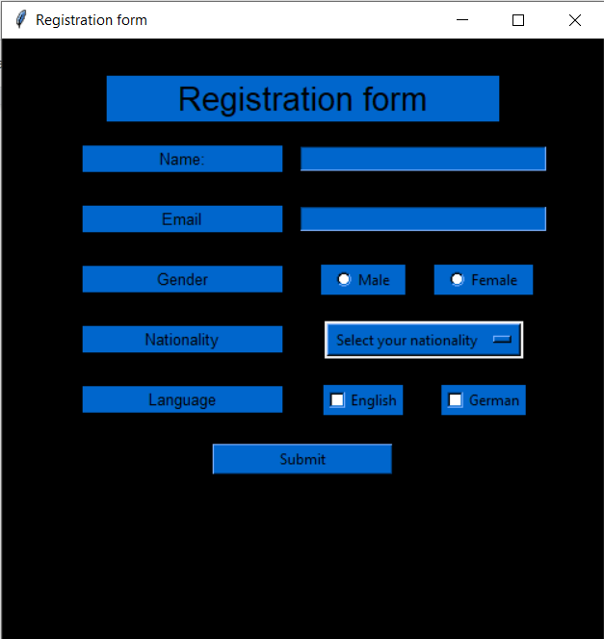

**A sample filled registration form:**

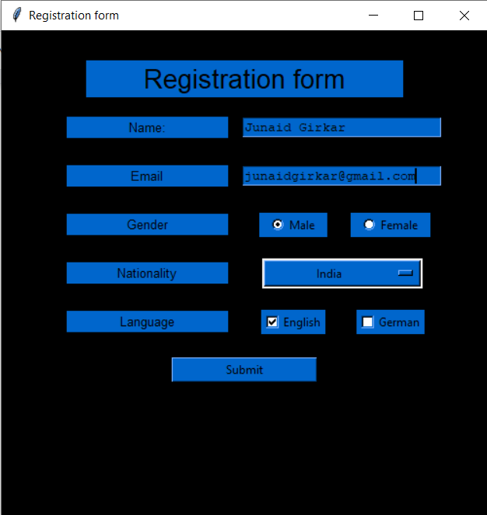

**Alert (pop-up) on submission of form:**

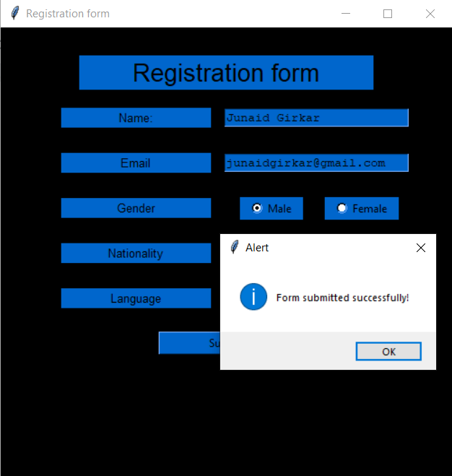

**Conclusion**

**Tkinter** is a Python library for developing GUI applications. It is built in Python. **Tkinter** provides us with a variety of widgets such as buttons, menus and various kinds of entry fields and display areas which we can use to build our interface. In this experiment, we created a registration form using tkinter Label, Radiobutton, OptionMenu, Button, Checkbutton and Text widgets.